**9. ReactJS-HOL**

**App.js:**

import React from 'react';

import ListofPlayers from './components/ListofPlayers';

import IndianPlayers from './components/IndianPlayers';

function App() {

  const flag = true;

  return (

    <div>

      {flag ? <ListofPlayers /> : <IndianPlayers />}

    </div>

  );

}

export default App;

**IndianPlayers.js:**

import React from 'react';

const IndianPlayers = () => {

  const players = ['Sachin1', 'Dhoni2', 'Virat3', 'Rohit4', 'Yuvaraj5', 'Raina6'];

  const [first, second, third, fourth, fifth, sixth] = players;

  const T20Players = ['First Player', 'Second Player', 'Third Player'];

  const RanjiTrophyPlayers = ['Fourth Player', 'Fifth Player', 'Sixth Player'];

  const mergedPlayers = [...T20Players, ...RanjiTrophyPlayers];

  return (

    <div>

      <h2>Odd Players</h2>

      <ul>

        <li>First : {first}</li>

        <li>Third : {third}</li>

        <li>Fifth : {fifth}</li>

      </ul>

<hr />

      <h2>Even Players</h2>

      <ul>

        <li>Second : {second}</li>

        <li>Fourth : {fourth}</li>

        <li>Sixth : {sixth}</li>

      </ul>

<hr />

      <h2>List of Indian Players Merged:</h2>

      <ul>

        {mergedPlayers.map((player, index) => (

          <li key={index}>Mr. {player}</li>

        ))}

      </ul>

    </div>

  );

};

export default IndianPlayers;

**ListofPlayers.js:**

import React from 'react';

const ListofPlayers = () => {

  const players = [

    { name: 'Mr. Jack', score: 50 },

    { name: 'Mr. Michael', score: 70 },

    { name: 'Mr. John', score: 40 },

    { name: 'Mr. Ann', score: 61 },

    { name: 'Mr. Elisabeth', score: 61 },

    { name: 'Mr. Sachin', score: 95 },

    { name: 'Mr. Dhoni', score: 100 },

    { name: 'Mr. Virat', score: 84 },

    { name: 'Mr. Jadeja', score: 64 },

    { name: 'Mr. Raina', score: 75 },

    { name: 'Mr. Rohit', score: 80 }

  ];

  const players70 = [];

  players.map((item) => {

    if (item.score <= 70) {

      players70.push(item);

    }

    return null;

  });

  return (

    <div>

      <h2>List of Players</h2>

      <ul>

        {players.map((item, index) => (

          <li key={index}>

            {item.name} <span>{item.score}</span>

          </li>

        ))}

      </ul>

<hr />

      <h2>List of Players having Scores Less than 70</h2>

      <ul>

        {players70.map((item, index) => (

          <li key={index}>

            {item.name} <span>{item.score}</span>

          </li>

        ))}

      </ul>

    </div>

  );

};

export default ListofPlayers;

**OUTPUT:**

**When flag=false:**

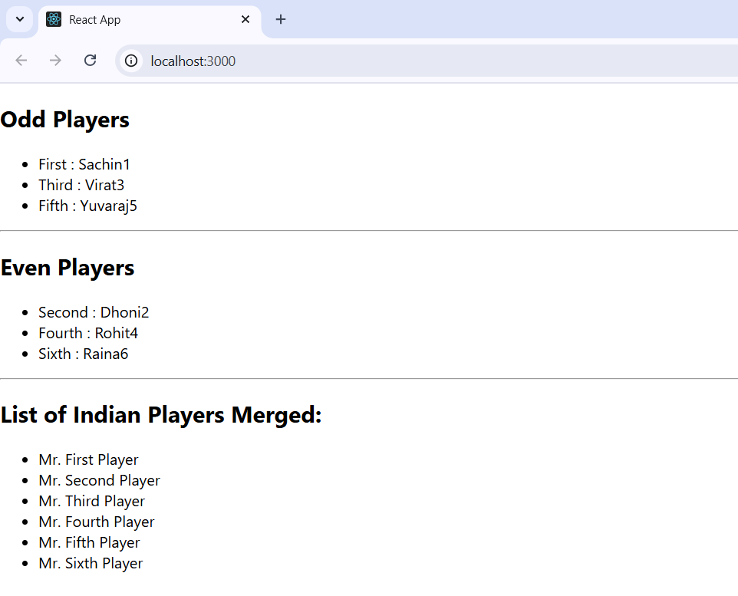

**When flag=true:**

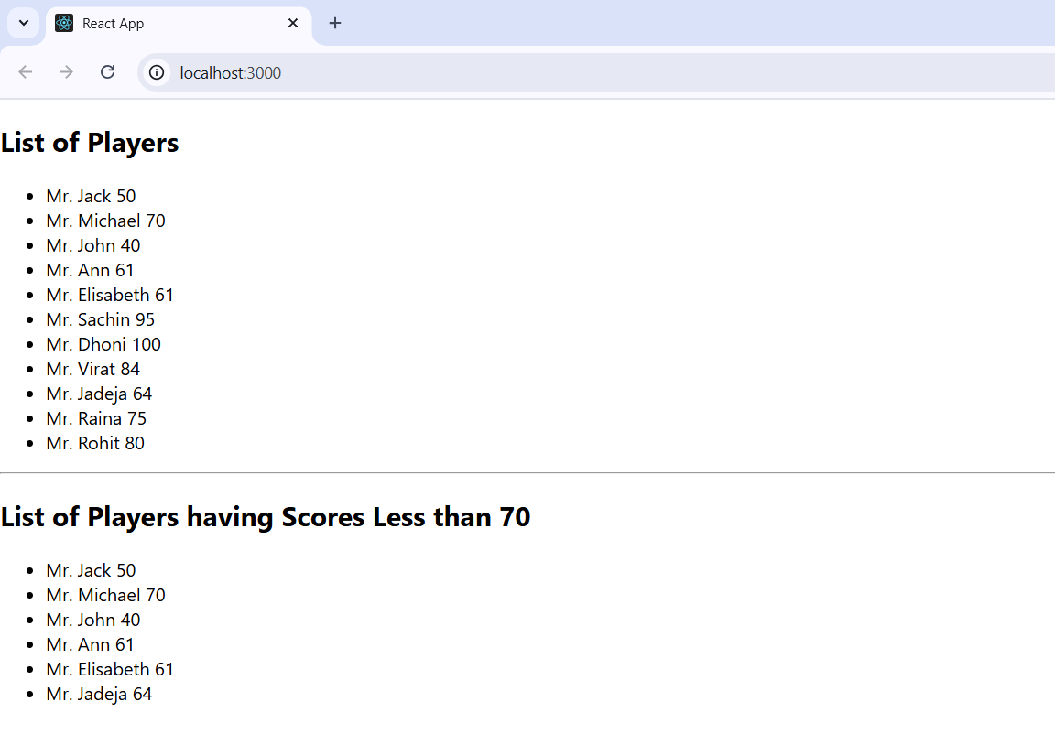

**10. ReactJS-HOL**

**App.js:**

import React from 'react';

import './App.css';

function App() {

  const officeList = [

    {

      name: 'DBS',

      rent: 50000,

      address: 'Chennai',

      image: 'https://png.pngtree.com/background/20230604/original/pngtree-modern-corporate-business-office-background-wallpaper-picture-image_2873050.jpg'

    },

    {

      name: 'WeWork',

      rent: 65000,

      address: 'Bangalore',

      image: 'https://businessfirstfamily.com/wp-content/uploads/2015/09/corporate-office-interior-design.jpg'

    },

    {

      name: 'Regus',

      rent: 55000,

      address: 'Mumbai',

      image: 'https://wallpapers.com/images/featured/hd-office-background-wwmb5ymdbjbjv689.jpg'

    }

  ];

  return (

    <div className="container">

      <h1>Office Space, at Affordable Range</h1>

      {officeList.map((office, index) => {

        // Conditional class assignment based on rent

        const rentClass = office.rent <= 60000 ? 'textRed' : 'textGreen';

        return (

          <div key={index} className="card">

            <img src={office.image} alt={office.name} className="office-img" />

            <h2>Name: {office.name}</h2>

            <p className={rentClass}>Rent: Rs. {office.rent}</p>

            <p><strong>Address:</strong> {office.address}</p>

          </div>

        );

      })}

    </div>

  );

}

export default App;

**App.css:**

.container {

  padding: 30px;

  text-align: center;

  font-family: Arial, sans-serif;

}

h1 {

  font-size: 24px;

  font-weight: bold;

}

.card {

  margin: 30px auto;

  width: 300px;

  border: 1px solid #ccc;

  padding: 15px;

  border-radius: 8px;

}

.office-img {

  width: 100%;

  height: auto;

  border-radius: 4px;

  margin-bottom: 15px;

}

.textRed {

  color: red;

  font-weight: bold;

}

.textGreen {

  color: green;

  font-weight: bold;

}

**OUTPUT:**

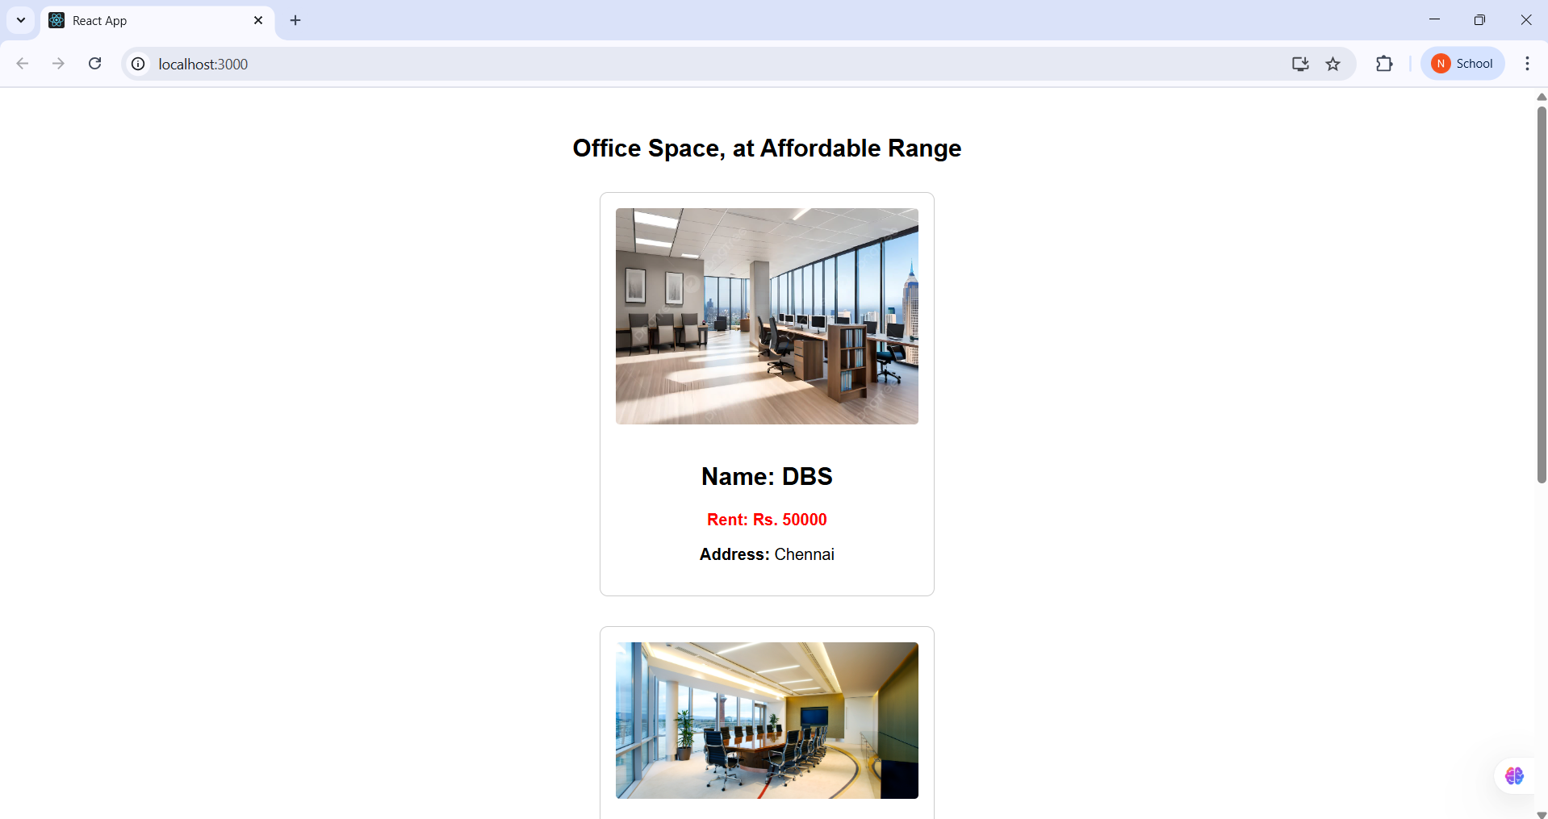

**11. ReactJS-HOL**

**App.js:**

import React, { Component } from 'react';

import CurrencyConvertor from './CurrencyConvertor';

class App extends Component {

  constructor(props) {

    super(props);

    this.state = {

      count: 0

    };

  }

  handleIncrement = () => {

    this.setState((prevState) => {

      const newCount = prevState.count + 1;

      alert(`Hello Member ${newCount}`);

      return { count: newCount };

    });

  };

  decrement = () => {

    this.setState({ count: this.state.count - 1 });

  };

  sayWelcome = () => {

    alert("Welcome!");

  };

  handlePress = () => {

    alert("I was clicked");

  };

  render() {

    const buttonStyle = {

      display: 'block',

      marginBottom: '10px',

      padding: '5px 10px'

    };

    return (

      <div style={{ margin: '20px' }}>

        <div>{this.state.count}</div>

        <button style={buttonStyle} onClick={this.handleIncrement}>Increment</button>

        <button style={buttonStyle} onClick={this.decrement}>Decrement</button>

        <button style={buttonStyle} onClick={this.sayWelcome}>Say welcome</button>

        <button style={buttonStyle} onClick={this.handlePress}>Click on me</button>

        <CurrencyConvertor />

      </div>

    );

  }

}

export default App;

**CurrencyConvertor.js:**

import React, { Component } from 'react';

class CurrencyConvertor extends Component {

  constructor(props) {

    super(props);

    this.state = {

      amount: '',

      currency: ''

    };

  }

  handleAmountChange = (event) => {

    this.setState({ amount: event.target.value });

  };

  handleCurrencyChange = (event) => {

    this.setState({ currency: event.target.value });

  };

  handleSubmit = (event) => {

    event.preventDefault();

    const { amount, currency } = this.state;

    const convertedAmount = amount * 80;

    alert(`Converting to ${currency} Amount is ${convertedAmount}`);

  };

  render() {

    const labelStyle = {

      fontWeight: 'bold',

      marginRight: '10px',

      display: 'inline-block',

      width: '80px'

    };

    const inputStyle = {

      marginBottom: '10px',

      padding: '5px',

      width: '150px'

    };

    const formGroupStyle = {

      marginBottom: '10px',

      display: 'flex',

      alignItems: 'center'

    };

    const headingStyle = {

      fontSize: '24px',

      fontWeight: 'bold',

      color: 'green',

      marginTop: '30px',

      marginBottom: '20px'

    };

    return (

      <div>

        <h3 style={headingStyle}>Currency Convertor!!!</h3>

        <form onSubmit={this.handleSubmit}>

          <div style={formGroupStyle}>

            <label style={labelStyle}>Amount:</label>

            <input

              type="number"

              value={this.state.amount}

              onChange={this.handleAmountChange}

              style={inputStyle}

              required

            />

          </div>

          <div style={formGroupStyle}>

            <label style={labelStyle}>Currency:</label>

            <input

              type="textarea"

              value={this.state.currency}

              onChange={this.handleCurrencyChange}

              style={inputStyle}

              required

            />

          </div>

          <button type="submit" style={{ padding: '5px 15px' ,marginLeft: '90px' }}>

            Submit

          </button>

        </form>

      </div>

    );

  }

}

export default CurrencyConvertor;

**index.js:**

import React from 'react';

import ReactDOM from 'react-dom/client'; // Make sure you're using React 18

import App from './App';

const root = ReactDOM.createRoot(document.getElementById('root'));

root.render(<App />);

**OUTPUT:**

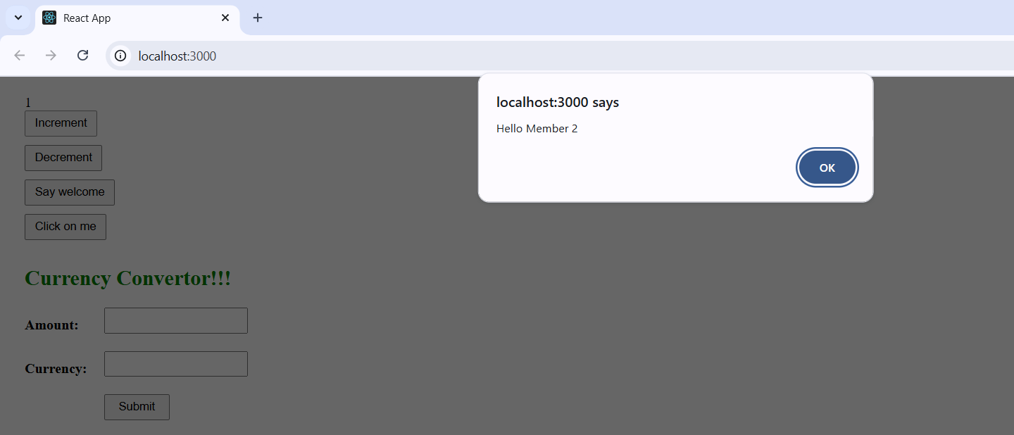

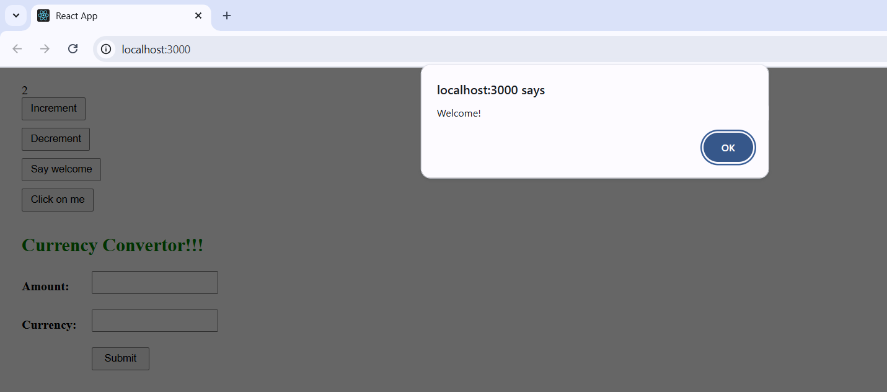

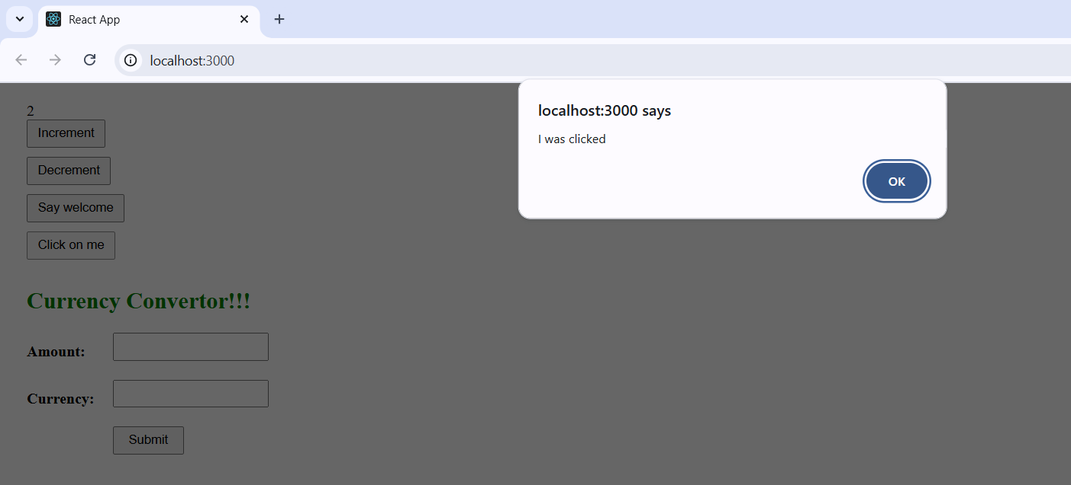

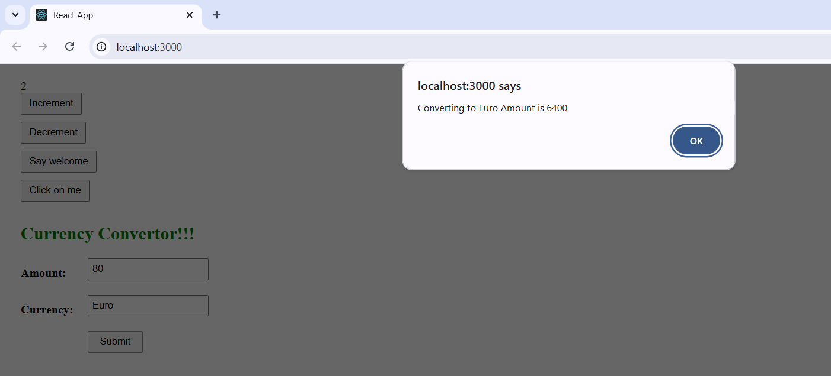

**12. ReactJS-HOL**

**App.js:**

import React, { useState } from 'react';

const GuestGreeting = () => <h2>Please sign up.</h2>;

const UserGreeting = () => <h2>Welcome back</h2>;

const Greeting = ({ isLoggedIn }) =>

  isLoggedIn ? <UserGreeting /> : <GuestGreeting />;

const LoginButton = ({ onClick }) => (

  <button onClick={onClick}>Login</button>

);

const LogoutButton = ({ onClick }) => (

  <button onClick={onClick}>Logout</button>

);

const App = () => {

  const [isLoggedIn, setIsLoggedIn] = useState(false);

  const toggleLogin = () => setIsLoggedIn(!isLoggedIn);

  return (

    <div style={{ padding: '30px', fontFamily: 'Arial' }}>

      <h1>Ticket Booking App</h1>

      <Greeting isLoggedIn={isLoggedIn} />

      {isLoggedIn ? (

        <LogoutButton onClick={toggleLogin} />

      ) : (

        <LoginButton onClick={toggleLogin} />

      )}

      <hr />

      <h2>Flight Details</h2>

      <ul>

        <li>AI-101 | Delhi → New York | 9:00 AM</li>

        <li>BA-202 | Mumbai → London | 11:30 AM</li>

      </ul>

      {isLoggedIn && (

        <>

          <h2>Book Your Ticket</h2>

          <form onSubmit={e => { e.preventDefault(); alert('Ticket booked!'); }}>

            <label>

              Name: <input required />

            </label><br /><br />

            <label>

              Flight:

              <select required>

                <option value="">-- Select --</option>

                <option>AI-101</option>

                <option>BA-202</option>

              </select>

            </label><br /><br />

            <button>Book Ticket</button>

          </form>

        </>

      )}

    </div>

  );

};

export default App;

**index.js:**

import React from 'react';

import ReactDOM from 'react-dom/client';

import App from './App';

ReactDOM.createRoot(document.getElementById('root')).render(<App />);

**OUTPUT:**

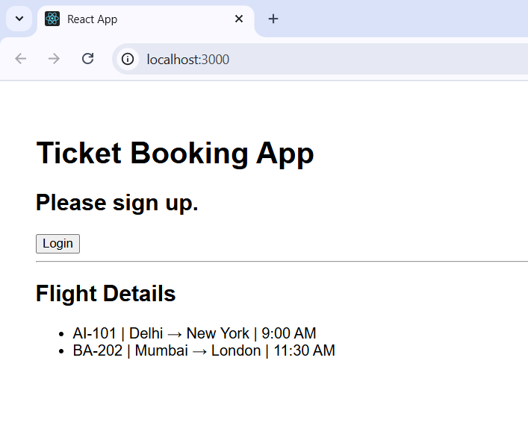

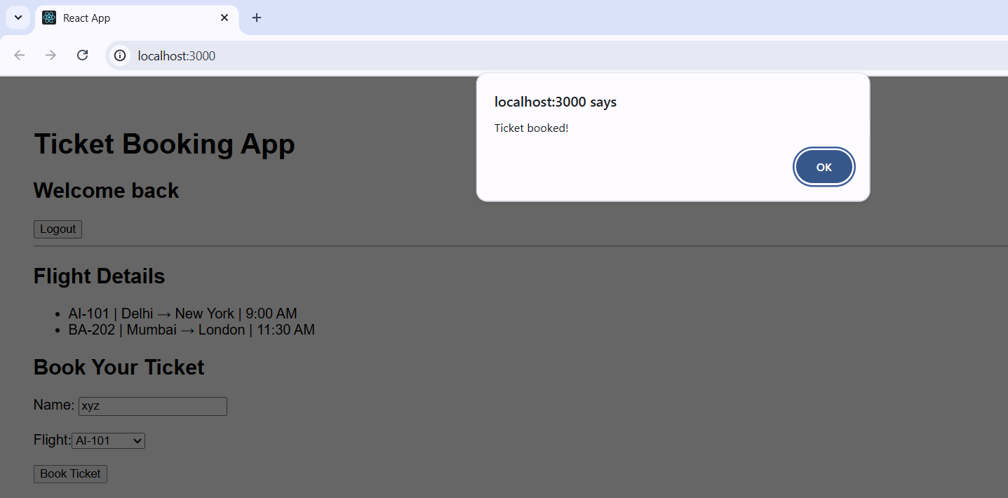

**13. ReactJS-HOL**

**BlogDetails.js:**

import React from "react";

function BlogDetails() {

  const isLoggedIn = true;

  const content = isLoggedIn ? (

    <>

      <h1> Blog Details</h1>

      <h1> React Learning</h1>

      <strong>Stephen Biz</strong>

      <p>Welcome to learning React!</p>

      <h1>Installation</h1>

      <strong>Schwezdienier</strong>

      <p>You can install React from npm.</p>

    </>

  ) : (

    <p>Please log in to view blogs.</p>

  );

  return <div className="section">{content}</div>;

}

export default BlogDetails;

**BookDetails.js:**

import React from "react";

const books = [

  { id: 101, bname: "Master React", price: 670 },

  { id: 102, bname: "Deep Dive into Angular 11", price: 800 },

  { id: 103, bname: "Mongo Essentials", price: 450 },

];

function BookDetails() {

  const showBooks = true;

  return (

    <div className="section">

      <h1>Book Details</h1>

      {showBooks ? (

        <ul>

          {books.map((book) => (

            <div key={book.id}>

              <h3>{book.bname}</h3>

              <h4>{book.price}</h4>

            </div>

          ))}

        </ul>

      ) : (

        <p>No books to display</p>

      )}

    </div>

  );

}

export default BookDetails;

**CourseDetails.js:**

import React from "react";

function CourseDetails() {

  const courses = [

    { id: 1, name: "Angular", date: "4/5/2021" },

    { id: 2, name: "React", date: "6/3/20201" },

  ];

  const coursedet = (

    <>

      {courses.map((course) => (

        <div key={course.id}>

          <h2>{course.name}</h2>

          <p>{course.date}</p>

        </div>

      ))}

    </>

  );

  return (

    <div>

      <h1>Course Details</h1>

      {coursedet}

    </div>

  );

}

export default CourseDetails;

**App.css:**

.container {

  display: flex;

  justify-content:center;

  padding: 30px;

}

.section {

  border-left: 4px solid green;

  padding-left: 10px;

  padding-right:10px;

}

h1 {

  font-size: 24px;

  font-weight: bold;

}

h2 {

  font-size: 20px;

  font-weight: bold;

}

h3 {

  font-size: 18px;

}

p, h4, strong {

  margin: 10px 0;

}

**App.js:**

import React from "react";

import BookDetails from "./components/BookDetails";

import BlogDetails from "./components/BlogDetails";

import CourseDetails from "./components/CourseDetails";

import "./App.css";

function App() {

  return (

    <div className="container">

      <CourseDetails />

      <BookDetails />

      <BlogDetails />

    </div>

  );

}

export default App;

**OUTPUT:**

